Multiple-choice section – choose the correct answer

Question 1 [2.3]

The hypotenuse of a right-angled triangle is 19 cm in length. One of the shorter sides is 14 cm. What is the value of the third side?

A cm B cm C  cm D cm

Question 2 [2.1]

Which of the following statements is true?

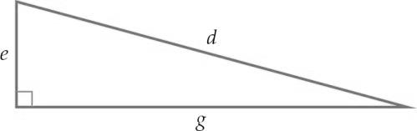

A *d*2 + *e*2 = *g*2 B  C *d*2 – *g*2 = *e*2 D 

Question 3 [2.5]

If *a* = 15 and *b* = 20, and *a*, *b* and *c* form a Pythagorean triple, what is the value of *c*?

A 25 B 5 C 30 D 35

Question 4 [2.2]

Calculate the length of the hypotenuse to 2 decimal places.

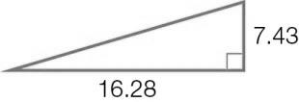

A 14.48 B 14.49 C 17.89 D 17.90

Question 5 [2.2]

Which statement about  is *not* correct?

A  is approximately 3.87.

B  is a surd.

C  is a rational number.

D = 15

Question 6 [2.4]

A ladder leans against a vertical wall. Its base is 1.5 metres from the bottom of the wall and its top is 2 metres above the ground. If the ladder is moved so that its base is now 1 metre from the bottom of the wall, which one of these statements is true?

A There is not enough information to find the new height of the top of the ladder.

B The top of the ladder is now 1.5 m above the ground.

C The height of the top of the ladder is now 2.5 m.

D A calculation using Pythagoras’ theorem is needed to find the new height of the top of the ladder.

Question 7 [2.2]

What is the value of the diagonal to 2 decimal places?

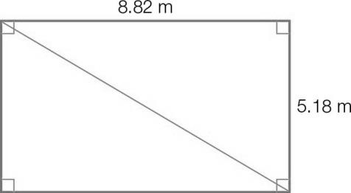

A 10.23 B 14.00 C 7.14 D 8.13

Question 8 [2.5]

Which one of the following sets of numbers forms a Pythagorean triple?

A (3, 6, 9) B (14, 25, 50) C (8, 15, 17) D (11, 50, 51)

Multiple-choice results: ___ / 8

Short answer section

Question 9 3 marks [2.1, 2.2, 2.5]

Use words from the list below to complete the following sentences.

Pythagorean triples surd exact approximate rational  
irrational longer shorter opposite beside  
square square root theorem

**(a)** In a right-angled triangle, the hypotenuse is _____________ the right angle.

**(b)** To find the length of the hypotenuse, we take the _____________ of the sum of the squares  
 of the two _______ sides.

**(c)** By showing that the numbers in ______________ satisfy Pythagoras’ ________, we show that these numbers could represent the lengths of sides of a right-angled triangle.

**(d)** A square root that is an irrational number is called a _____.

Question 10 3 marks [2.3]

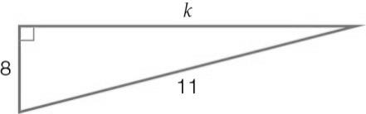

Maha and Nino both attempt to use Pythagoras’ theorem to calculate the value of *k* in this diagram.

**(a)** Find the incorrect step(s) in each solution. Circle the first line of working that is incorrect.

Maha: 82 + 112 = *k*2 Nino: 112 – 82 = *k*

64 + 121 = *k*2 32 = *k*2

175 = *k*2 9 = *k*2

= *k*  = *k*

*k* = 13.23 *k* = 3

**(b)** Explain the mistakes that each has made.

Maha:

_________________________________________________________________________

_________________________________________________________________________

Nino:

_________________________________________________________________________

_________________________________________________________________________

Question 11 2 marks [2.1]

Which of the following triangles contains a right angle? Use the converse of Pythagoras’ theorem to justify your answer.

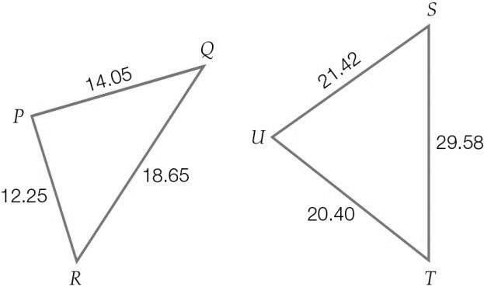

Question 12 2 marks [2.1]

Write an appropriate statement of Pythagoras’ theorem (in the form of an equation) for these triangles.

**(a) (b)**

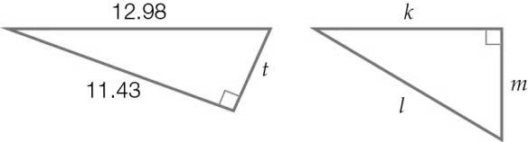

Question 13 1 mark [2.1]

Use a ruler to construct a right-angled triangle with side lengths of 5 cm, 3 cm and 4 cm. Label the hypotenuse and the right angle.

Question 14 2 marks [2.2]

Determine the value of the pronumeral in this triangle to 2 decimal places.

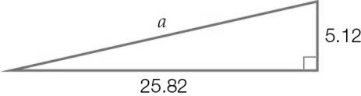

Question 15 2 marks [2.2]

Find the length of the hypotenuse in exact (surd) form.

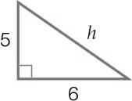

Question 16 2 marks [2.3]

Find the value of the unknown side in this right-angled triangle, to 2 decimal places.

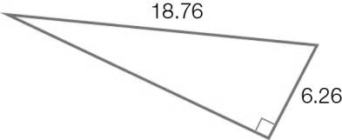

Question 17 2 marks [2.3]

Find the value of the pronumeral in the following right-angled triangle, in exact (surd) form.

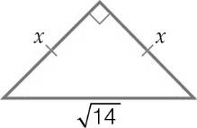

Question 18 2 marks [2.3]

Find the value of *m* in the following diagram, correct to 2 decimal places.

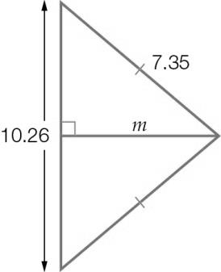

Question 19 3 marks [2.4]

A ladder of length 1.8 m is leaning against the wall. Its base is 0.9 m from the wall. A picture is hanging at a height of 1.65 m. What is the difference between the height of the ladder and the height of the picture? (Give your answer in centimetres, to the nearest whole number.)

Question 20 3 marks [2.4]

A pole is supported by two ropes, each of length 370 cm, which are pegged to the ground as shown. Assume that a straight line can be drawn from peg to peg and that the pole is located at the midpoint of this line. The pole is 350 cm high. What is the distance between the two pegs, in centimetres?

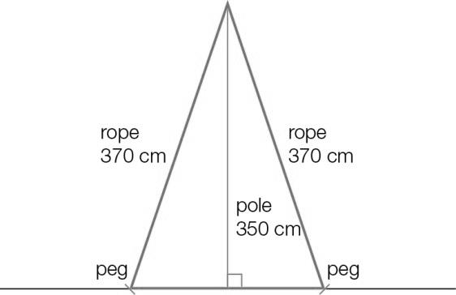

Question 21 2 marks [2.5]

Replace the pronumeral with a positive integer to form a Pythagorean triple.

(a) (5, *b*, 13) (b) (9, 40, *h*)

Question 22 2 marks [2.5]

Using Pythagoras’ theorem, determine whether or not the following sets of numbers could be classified as Pythagorean triples.

(a) (15, 63, 65) (b) (20, 21, 29)

Short answer results: ___ / 31

Extended answer section

Question 23 5 marks [2.1]

Lou is renovating her house and wants to check that her plan for one of her rooms is ‘square’. She measures the length of the room’s floor as 4.45 m, the width as 3.40 m, and the diagonal across the room as 5.70 m.

(a) Sketch a diagram (scale is not important) to represent the floor plan of the room in question.

(b) Use the converse of Pythagoras’ theorem to show that the planned room is not ‘square’.

(c) Suggest how Lou can adjust the length, the width and the diagonal on the plan to ensure that they meet at right angles. Use calculations to show that your answer will ensure that the room is ‘square’.

Question 24 9 marks [2.2, 2.4]

Mark walks from the train station (point *A*) to his house (point *B*): he walks 700 m west, 1 km south and then 400 m west. Nuala walks from her house (point *C*) to the train station (point *A*). To do this, she walks 200 m north, 1.2 km west and then 500 m north.

(a) Draw a diagram (scale is not important) to represent the journeys of Mark and Nuala.

(b) Calculate the total distance Mark walks. Calculate the total distance Nuala walks. Who walks further and by what length?

(c) If a straight line is drawn from point *A* to point *B*, what is the length of this line?

(d) If a straight line is drawn from point *C* to point *A*, what is the length of this line?

(e) Use your previous two answers to determine who lives closer to the station and by what distance.

Question 25 5 marks [2.5]

(a) Find new Pythagorean triples by doubling each of the numbers in the following sets.

(i) (9, 12, 15) (ii) (24, 143, 145)

(b) Find new Pythagorean triples by completing the following table.

|  |  |  |  |
| --- | --- | --- | --- |
| *b* | ( *b*2– 1) | ( *b*2+ 1) | Triple |
| 7 |  |  |  |
|  | 112 |  |  |

(c) Find new Pythagorean triples by completing the following table.

|  |  |  |  |  |  |
| --- | --- | --- | --- | --- | --- |
| *g* | *h* | *g* + *h* | *gh* |  | Triple |
| 2 | 4 |  |  |  |  |
| 5 | 7 |  |  |  |  |

Extended answer results: ___ / 19

TOTAL test results: ___ / 58